🛠️ Step 1: Create Extended ACL
access-list 100 permit tcp 192.168.20.0 0.0.0.255 host 192.168.50.10 eq 80
access-list 100 deny ip any host 192.168.50.10
access-list 100 permit ip any any
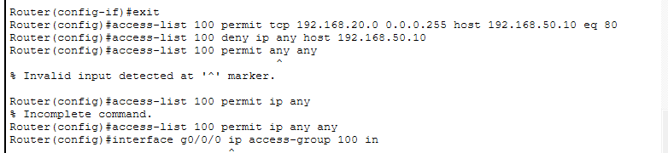
Apply:
interface g0/1
ip access-group 100 in
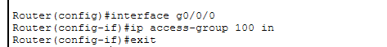

🛠️ Step 2: Disable Telnet (Security Best Practice)
line vty 0 4
transport input ssh
login local
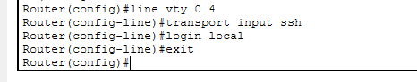

🛠️ Step 3: Configure SSH
hostname R1
ip domain-name net621.local
crypto key generate rsa
username admin password Cisco123
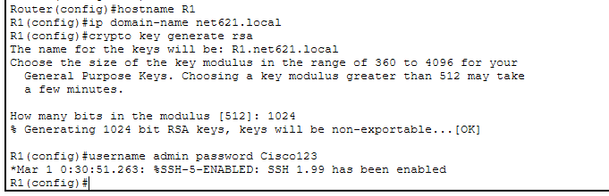

✅ Verification
ssh -l admin 192.168.1.1
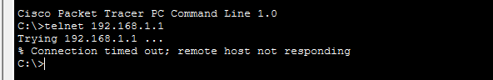
✔ Secure remote management enabled.

